My Baby and Me Pilot Project Evaluation

**2018**

Family Learning

Limerick and Clare Education and Training Board

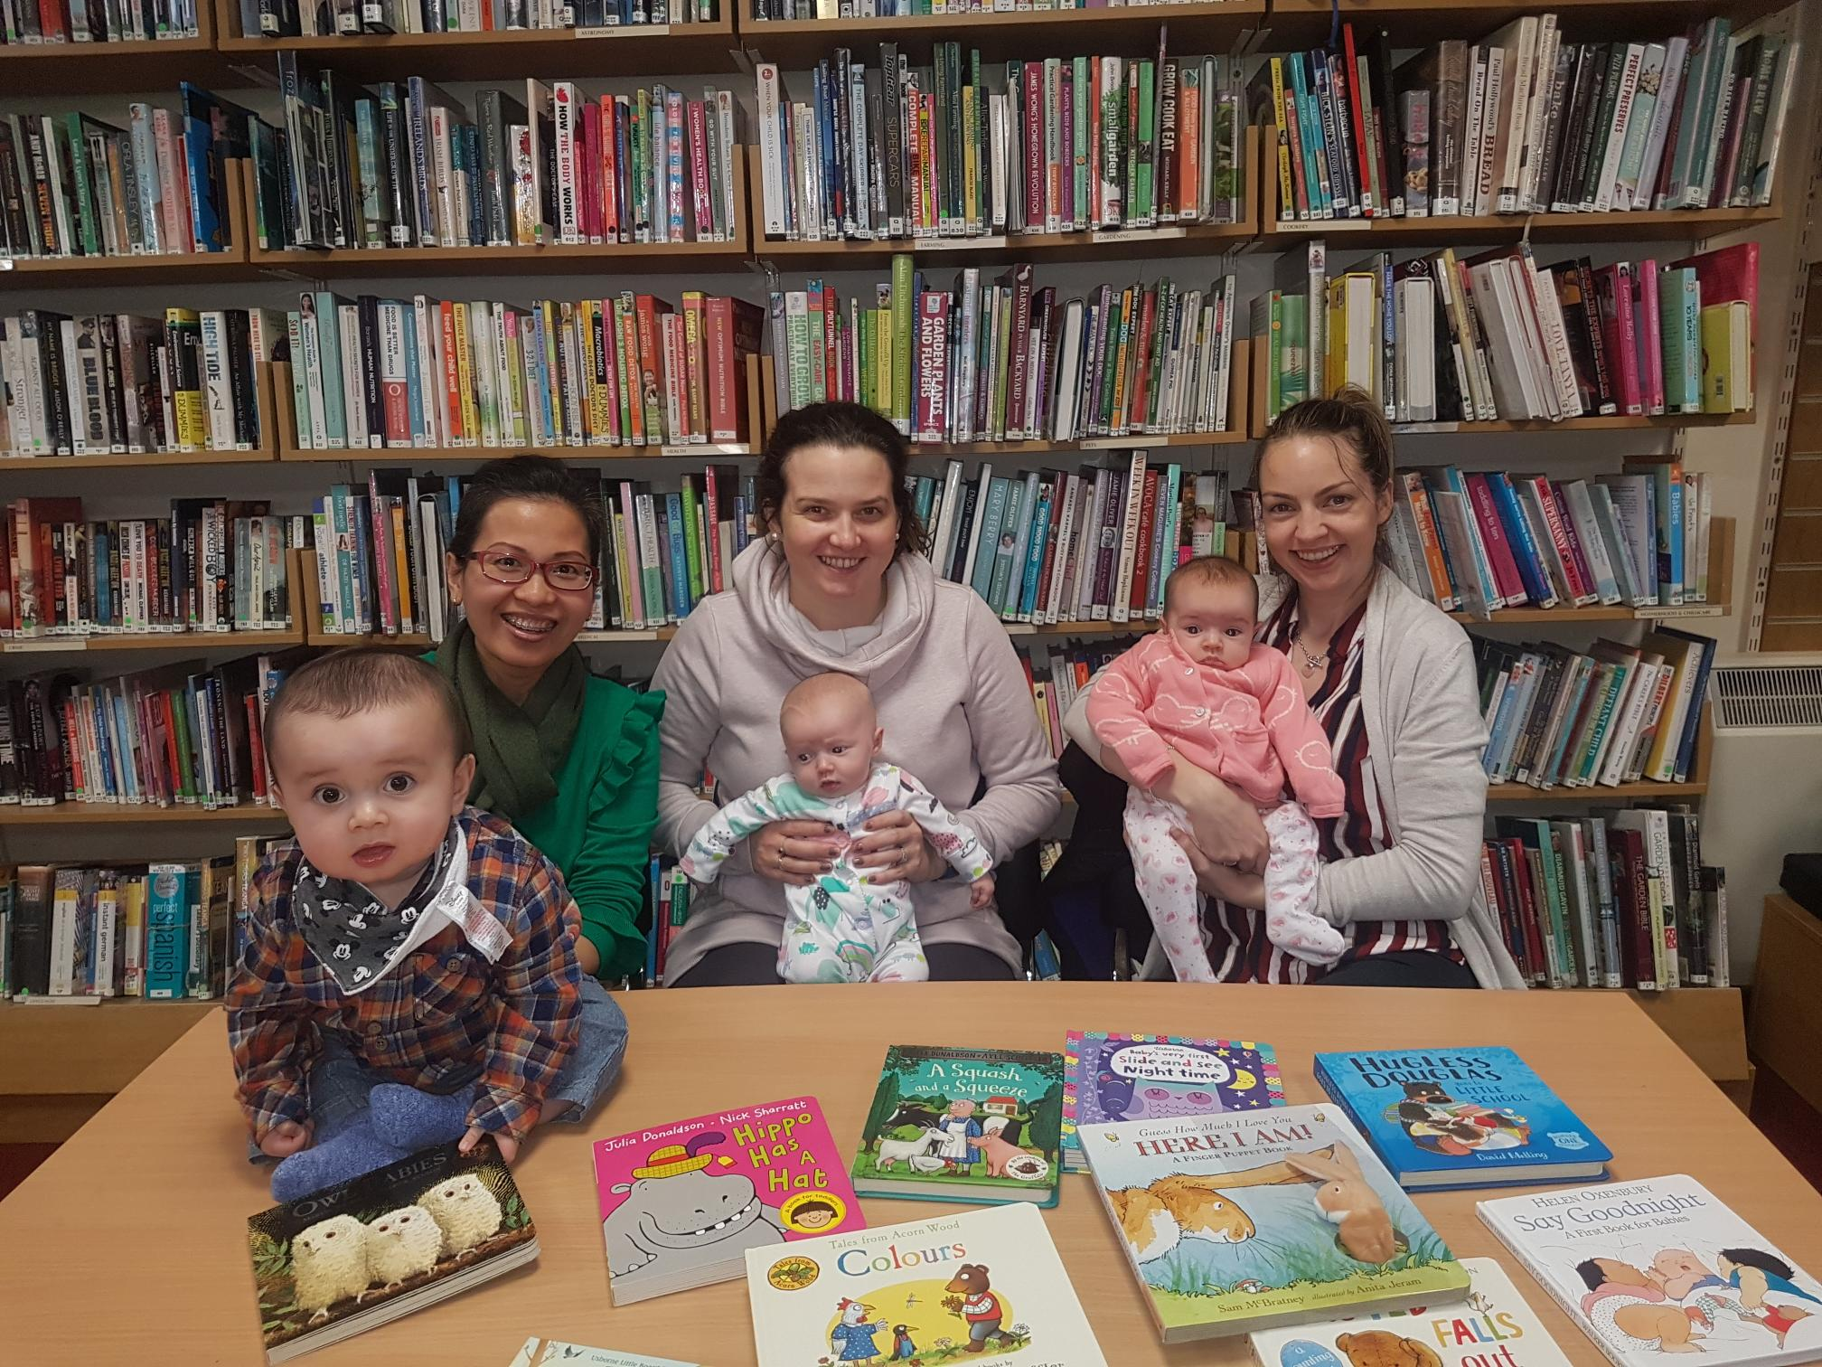

# Introduction

### *‘It is possible today to help our youngest readers learn to read more successfully than ever before, particularly by taking advantage of what many years of conclusive evidence from research assures us about the effectiveness of a balanced approach to reading instruction’* (Cowen, 2005). The beginning of literacy and numeracy development is embedded in the everyday communications, interactions, thoughts and actions of babies, toddlers and young children. Parents and the home learning environment are critically important in the development of both. Furthermore, there is a growing consensus that children’s early literacy and family learning experiences must involve a balance of varied experiences and activities (Cowen, 2005, Morrow and Gambrell, 2011, Pressely, 2006). Thus, effective literacy and numeracy development requires a combination of skills-based and whole language teaching in a motivating and supportive environment through rich learning opportunities (Pressley, 2006). Limerick and Clare Education and Training Board’s Family Learning provision in Co. Clare developed a pilot course, ‘*My Baby and Me*’ to respond to growing literacy needs from families and to support parents with poor literacy skills to improve and strengthen life chances for themselves and their baby through reading, oral language and returning to education. This report is an evaluation of the ‘*My Baby and Me*’ pilot project which is envisaged to inform good practice for Family Learning.

# Setting the Context

### A funding application was completed and submitted in April 2018 for Healthy Ireland Funding through the Children and Young Peoples’ Services Committee (CYPSC). Discussions with the local CYPSC Co-ordinator prior to sending the application revealed that priority would be given to ‘health focused’ criteria. As a result the application was sent in May to SOLAS, the Further Education and Training Authority. This application was successful and funding of €33,453 was provided to Limerick and Clare Education and Training Board for this Family Learning pilot project. (See Appendix 1 for costs.) The proposal contained a strong multimedia promotional focus to reach younger parents, and personal booklet and books for parent and baby to take home.

An Advisory and Support Group was established to support the work of ‘*My Baby and Me*’ pilot project. This included the Co. Clare Children’s Librarian, Speech and Language Therapist Manager for Clare, Coordinator of Children and Young Peoples’ Services Committee, Coordinator of Clare Immigrant Support Centre, Local Primary School Home School Community Liaison Coordinator, Social Worker, FET Manager, Adult Literacy Organiser Coordinator, as well as Family Learning staff. This multi-disciplinary approach ensured a holistic, parent-centred approach was taken. Furthermore, the pilot was founded on the National Literacy and Numeracy Strategy priority of enabling parents and communities to support children’s literacy and numeracy development (2011, p19). The Further Education and Training Strategy Review 2014-2017 ‘*recognises that the nature of the FET sector is itself complex and wide-ranging and must cater for a diverse range of social, economic and demographic learner cohorts*’. Every learner needs to be able to access the appropriate education and training to suit their needs. Some may be further from the start line and may need encouragement to return to learning. In 2017 the Barriers to Further Education and Training (FET) report mentioned ‘*the serious challenges encountered by learners from vulnerable groups seeking to engage with FET.* ’ My Baby and Me is a successful approach that allows learners to (re)start their education in an informal and flexible way, that allows their child attend, avoiding the added expense of childcare.

# Literature Review

The following draws on a review of the literature regarding literacy learning, and summarises what we know about emergent literacy:

* Literacy is not rooted in letters and words initially, but in communication and language. That is, non-verbal communication (smiling, gestures, pointing) and warm reciprocal relationships, particularly parent-child relationships. Therefore, literacy development starts from birth (Whitehead, 2007). Speaking, listening, reading and writing develop concurrently rather than sequentially (Epstein, 2007).
* Language and literacy learning happens naturally during play and everyday experiences. Some aspects, however, depend on clear instruction and interactions from responsive and sensitive adults. Through play all of the domains of a child’s development (social-emotional, cognitive, literacy and language, physical and spiritual) are interconnected and interdependent (Epstein, 2007, French, 2013).
* The greater children’s experiences of literacy and language, the greater the chance of reading fluency. However, the converse is also true. The fewer experiences children have with literacy and language (i.e. vocabulary and talk), the greater the chance that they will have difficulty learning to read (French, 2013).
* We know that children are “*most likely to experience conversations that include comprehensible and interesting extended discourse and are rich with vocabulary when their parents”* and educators *“obtain and read good books and provide classrooms with a curriculum that is varied and stimulating*” (Dickinson & Tabors, 2002, p. 13).
* Emergent early childhood literacy skills that have been identified as strong predictors of later literacy achievement include: a large vocabulary, being capable of explanatory talk, demonstrating some letter identification before age five, understanding narrative and story, understanding writing functions, knowing nursery rhymes, and demonstrating phonological awareness (Strickland & Riley-Ayers, 2006).
* It is what parents, carers and educators dowith children (reading with children, sharing stories, imaginative play, sensory play, talking to them), more so than their socio-economic status, which makes the difference to children’s literacy learning outcomes (Sylva, Melhuish, Sammons, Siraj-Blatchford and Taggart, 2004).

The research shows children’s exposure to a broad vocabulary range, through parent and child interactions, has clear implications for not only early education practice but lifelong effects. There is a vital need to develop children’s language and communication skills from birth. Such findings highlight the need for interventions and programmes prior to the free early years offering to offset educational inequality to a significant extent.

# Rationale

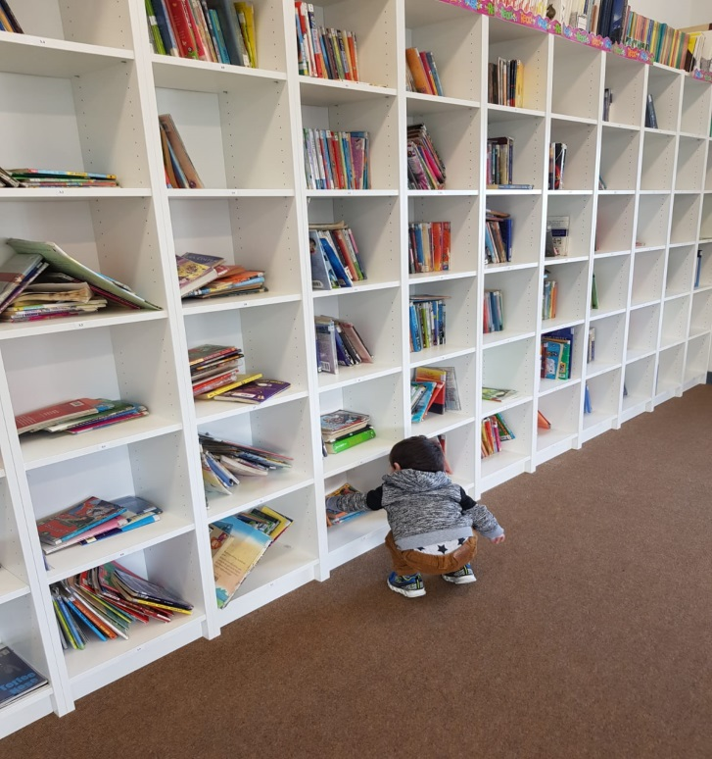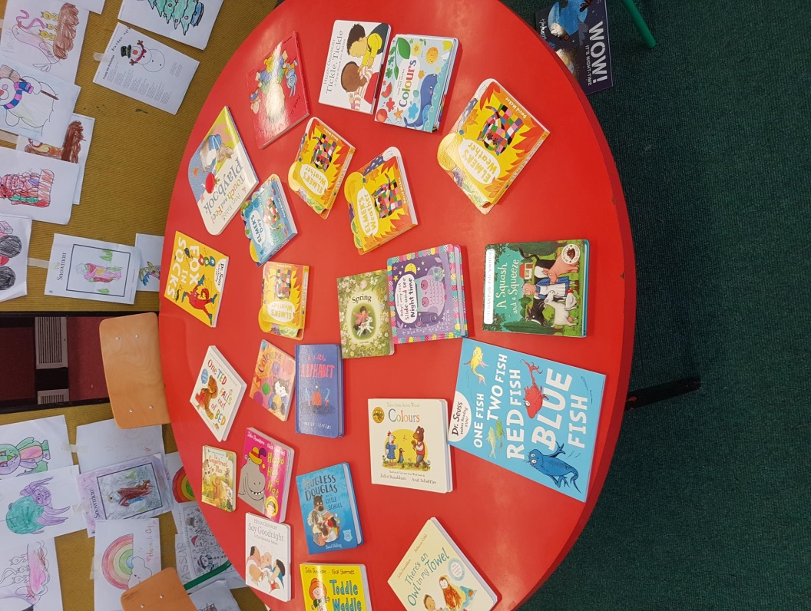A previous initiative with 10 courses ran between 2013-2015 funded through St. Vincent de Paul and Limerick and Clare Education and Training Board. This showed very positive impacts on strengthening family functioning and relationships. It changed parent’s beliefs surrounding education within the home and allowed parents a first step back to education. It was difficult to engage parents under 25 and it was felt a strong promotional campaign might help to recruit these priority parents. This formed the basis to deliver the ‘*My Baby and Me*’ pilot project.

# Aims and Objectives

The course aimed to:

* provide parents with a positive, stimulating and friendly learning environment;
* increase parent and child interaction on literacy/numeracy activities at home;
* encourage reading together at home by providing a free book per family in each class;
* provide social opportunities for parents and children to meet others and share useful ideas on supporting your child’s learning;
* encourage parents to become positive role models for their children as lifelong learners;
* engage young and early school leaver parents.

# Outline of the Programme

The programme is an eight week course designed to explore eight key themes/messages (see Appendix 2) for babies’ development and well-being in an experiential and fun way. Parents were encouraged to attend the sessions with their babies (and other children aged 0 - 3) and discover the variety of ways which day-to-day activities can contribute to their children’s learning and development. With a welcoming, informal atmosphere, ‘*My Baby and Me*’ offered a relaxed space in which parents could socialise, spend quality time with their babies and take away practical information on learning in the home. The programme is offered free-of-charge to participants. Parents and children created a ‘*My Baby and Me*’ Booklet and each week parents and children take home a book to create a library at home. Parents may not realise that simple things such as talking, singing and reading to their baby can have a huge impact on learning and ensure that the intellectual, physical, emotional and social needs of their children are met. This course provided ample opportunities for pre-school learning, to read new books, enjoy new sounds and make new friends.

# ‘*My Baby and Me*’ Booklet

The ‘*My Baby and Me*’ book is a Family Learning book created by Limerick and Clare Education and Training Board. Each page gives parents an opportunity to explore eight key themes in an experiential and fun way together with their babies. The themes explored include: Reading with your Baby; Mirroring; The importance of touch; Exploring the world together; Talk and listen to me; Sing with me; Play with me and Move with me. Parents print photographs of their baby and family members which will then be added to the characters in the book. There is also space at the front and back of the book for a group picture. Parents take this book home as a keepsake, a resource and a reminder of the themes explored.

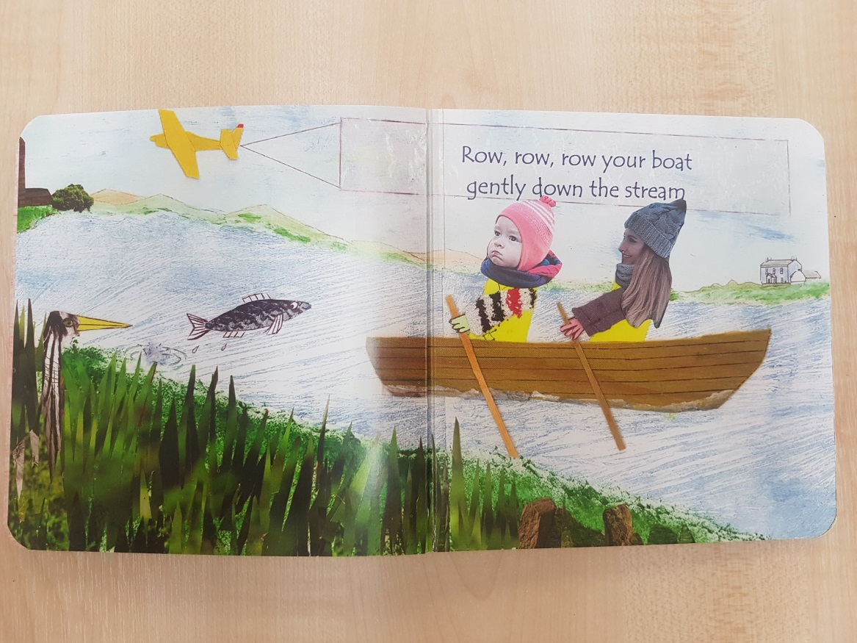

# Recruitment

A large marketing campaign was completed including local newspaper advertisements, radio advertisements and an online short video that was shared on digital platforms. The video received over 12,000 hits within two weeks of being released. Six locations were initially identified for the programme to take place; Ennis, Ennistymon, Kilrush, Scariff, Shannon and Kilkee. Venues included two primary schools and libraries in other locations. These were close to where people lived and easy to drop in when leaving older children to school. Leaflets and posters were distributed to key venues in each location including libraries; family resource centres, public health nurses, doctor surgeries and local shops. However, booking in advance was slow prior to the start date of October 15th, with an average of two bookings per course. Parents expressed that they heard about the programme from multiple avenues, primarily the radio advertisement and family resource centres. The Home School Community Liaison Coordinator played a key role in recruiting the group in the primary school. It was found that making personal contact is still a strong method of recruitment.

# Working in Partnership

Limerick and Clare Education and Training Board Family Learning staff in Clare work use a partnership approach to maximize funding to reach as many priority parents as possible. Staff have good links with the local primary school and the library services which were used as venues and places to promote the courses. Staff across the wider community e.g. Public Health Nurses, social workers, etc. encouraged parents to attend. The promotional campaign helped organisations to hear about the courses and aided referrals

# Results

Ninety-four hours of tuition was provided with forty-five parents attending over six courses, reaching a total of forty two mothers and four fathers.

|  |  |  |
| --- | --- | --- |
| **Course Venue** | **Male** | **Female** |
| Ennis |  | 10 |
| Scariff |  | 6 |
| Killaloe | 1 | 4 |
| Ennistymon | 1 | 7 |
| Kilrush | 1 | 7 |
| Shannon | 1 | 8 |
| Total | 4 | 42 |

Due to low numbers in Kilkee, the venue was moved to Killaloe for a five week programme. The majority of parents were Irish, 26 out of 45, while other nationalities included Polish, Slovakian, Filipino, Nigerian, Spanish, Dutch, Swedish, Indonesian, British (2), German, and Taiwanese. Six had already attended other courses within the Further Education and Training Division, while the majority were new to Limerick and Clare Education and Training Board.

***Age Profile***: the age profile of the participants varied with the main age category between thirty years old to forty years old. It proved difficult to meet the target group of young parents and it was discussed that a social media campaign may increase the probability of younger age groups attending the programmes.

|  |  |
| --- | --- |
| **Age** | **Participants** |
| Under 25 | 3 |
| 26-28 | 3 |
| 28-30 | 6 |
| 31-34 | 11 |
| 35-38 | 13 |
| 39-42 | 9 |

***Economic Status***: Learners included twenty-eight employed, four unemployed, two inactive for other reasons and eleven engaged in home duties.

Types of benefit: Five participants responded that they were in receipt of Jobseekers Benefit or Allowance, three parents were in receipt of One Parent Family Payment; two Disability or Illness benefit, one Carers Allowance, one State Pension and seven parents did not respond to the payment they were receiving.

Seven parents did not specify education level, one had no formal education, eight had lower second level and nine attended some upper second level education, two having Level 6 and twenty attaining Level 7 or above. Both external and internal barriers impacted on participation, including ill-health, appointments, low levels of confidence, shift work. However, attendance was stable across the board.

# Parent Evaluation

The tutors and course co-ordinator held a series of evaluations both informal and formal in order to gauge the views of parents and carers who accessed the provision. An informal evaluation took place in the groups where parents were asked to discuss the programme and offer opportunities for the programme to enhance the course. As part of the Christmas celebration, the parents were asked to participate in semi-structured interviews or complete questionnaires. The evaluations offered a deeper insight into parent’s evaluations of the programme which will now be discussed in further detail.

Parents spoke of multiple benefits for their parent-child relationship and children’s development including strengthened attachment and social interactions. Parents spoke about the changes they had noticed in their children since they had started attending the provision including a growth in independence, an increase in social skills and preparation for the school setting:

*“It’s an opportunity for [child] to meet other children of similar age and learn how to share and play with them”*

*“I hadn’t realised how important my interactions with my baby were, before coming to this class”*

*“My baby was so shy when we started coming here. Now she is more friendly and can’t wait to meet all the other children here”*

*“I’ve just moved here so it is really nice to meet other parents in the area…. I’m at home on my own all day so I really needed to have an adult conversation”.*

Parents expressed that the group also offered multiple learning opportunities for both parents and babies. Parents spoke of gaining invaluable information from both the tutors and other parents, and an increase in awareness and confidence in their parenting practices. Skills discussed included, how to engage with their children, new different ways to enhance learning through play, the importance of literacy in the home and an insight into babies development:

*“It’s good to just know that you’re on the right track, some reassurance”*

*“I didn’t realise I could do so much to support her development”*

*“I don’t need to feel shy about wanting to sing to my baby now”*

*“I’m reading to my baby every day now. I thought she was too little for books”*

*“I didn’t know I am my baby’s first teacher. I was waiting for her to go to school so she would start learning. I can see now how she has already started her learning”.*

The evaluations also showed that family learning programmes are a stepping stone for parents to return to education. Parents stated that they were not aware of Limerick and Clare Education and Training Board and the provision offered. Parents also spoke of building positive relationships with the tutors and requested a follow-up programme to be introduced:

*“We really look forward to the weekly outing. I thought 8 weeks was long but now I will really miss it”*

*“I didn’t know this service was here, I think it’s great that it’s introducing the children into the library at such a young age”*

*“I really loved coming to the classes. I was feeling lonely before and wasn’t always sure how to deal with problems arising with my baby. I have been able to share and learn so much from this group”.*

**Conclusion and Recommendations**

The ‘*My Baby and Me*’ course is still in the early stages of development and therefore this evaluation study provides a baseline from which to monitor future progress. What is evident to date is that the course has the ability to contribute to a wide range of need identified by families and has made a notable initial progress towards achieving them. The strengths of the pilot project course lies in the links that have been forged with the local community and the potential of the provision to contribute to a wider programme of community development and target families who are most in need with a follow on course envisaged. A social media campaign with a very active element may increase the likelihood of younger age groups attending this type of course.

The course was an opportunity to create a specific ‘space’ just for parents and their babies and toddlers that was both informal and structured. Each theme explored every week offered a good container for conversation and discussions for parents. The course saw multiple benefits for both parents and babies including an opportunity to socialise, avoid isolation, increase community integration, enhance learning opportunities, gain independence and confidence and, strengthen family literacy and learning in the home. Upon evaluating the course and tutor feedback it was noted that offering the course for children zero to three years may be too ambitious, attempting to meet too many needs. It was difficult for the tutor to work constructively with older toddlers and babies in the same session.

Retaining the flexibility to add extra classes to meet the requests of parents is important. Parents asked for a first-aid class and were anxious about delays in language development. A planned follow on course ‘*Healthy Babies*’ is aimed at responding to the identified needs of the parents and it is hoped a visit will be organised from the relevant specialist including the Public Health Nurse and the Speech and Language Therapist. Building strong relationships and having experienced tutors who empathize with what parents are going through is imperative. ‘*Literacy that begins in the home can be supported by the family as the lifelong learning journey begins for each child’* (Flanagan, 2015).

The results of both My Baby and Me pilot projects show that parents want to learn more. There are many ways of starting people on the journey to lifelong learning, My Baby and Me addresses the immediate needs of parents, this learning can be put into action when they get home. Trust is built up as parents feel listened to, this encourages people to ask questions and find out about other learning opportunities. This is a vital step for a vulnerable group of people some *‘... who are experiencing socio-economic exclusion and distance from education and/or the labour market’*. (Mooney & O’Rourke 2017)

**Summary of the Strengths of the ‘*My Baby and Me*’ Pilot Project**

* The pilot is community based and needs led
* Focuses activities on various aspects of play, learning and development by providing a range of stimulating activities within sessions
* An opportunity for socialising and elevating isolation
* Encourages both parents and children to learn through experience in order to increase independence and confidence
* Encourages families to become more involved in their local community, access local services and build strong community ties
* And provides a point of contact for Limerick and Clare Education and Training Board in terms of information and advice.

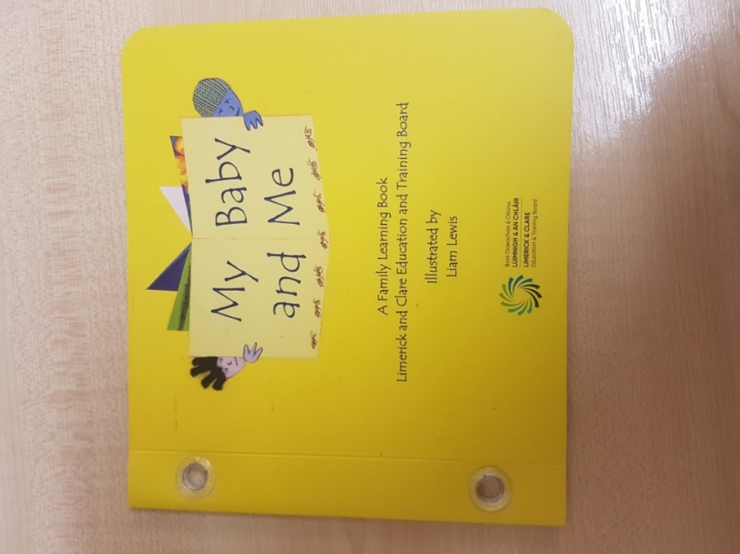

# References

Dickinson, D. & Tabors, P. (2002). Fostering Language and Literacy in Classrooms and Homes. *Young Children*. March (pp. 1-18). Washington: National Association for the Education of Young Children.

Epstein, A. (2007). *Essentials of Active Learning in Preschool.* Ypsilanti, MI: High/Scope Press.

French, G. (2012). *Literacy and Numeracy Matters: Enriching Literacy and Numeracy Experiences in Early Childhood*. Dublin: Barnardos.

Mooney, R., & O’Rourke, C. 2017. *Barriers to Further Education and Training with Particular Reference to Long Term Unemployed Persons and Other Vulnerable Individuals.* SOLAS

Solas. (2017). *High Level Progress Review of the FET Strategy 2014 – 2019.*

<http://www.solas.ie/SolasPdfLibrary/FET%20Review_Final_10_5%20(7).pdf> Accessed 30/01/2019

Strickland, D. & Riley-Ayers, S. (2006). *Early Literacy: Policy and Practice in the Preschool Years*. Policy Briefing 10: Rutgers, New Jersey: National Institute for Early Education Research.

Sylva, K., Melhuish, E., Sammons, P., Siraj-Blatchford, I. and Taggart, B. (2004). *Effective*

*Provision of Pre-School Education (EPPE) Project*: Final Report. London: DfES.

Whitehead, M. (2007). *Developing Language and Literacy with Young Children*. (3rd ed.)

London: Sage Publications Ltd.

Pressley, M., Mohan, L., Fingeret, L., Reffitt, K., and Raphael-Bogaert, L. (2007). Writing instruction in reading and effective elementary settings. In S. Graham, C. A., MacArthur, and J.Fitzgerald (Eds.), *Best practices in writing instruction* (pp. 13-27). New York: Guilford Press.

Morrow, L. M., and Gambrell, L. B. (2011). *Best practices in literacy instruction* (4th ed.). New York NY: Guilford Press.

**Appendix 1**

|  |  |  |  |  |  |  |
| --- | --- | --- | --- | --- | --- | --- |
| **My Baby and Me pilot 2018 Budget -** | | | |  | **€30,453** |  |
| **Date** | **P.O. No:** | **Amount €** | **Invoice No** | **Amount €** | **Balance c/fwd** | **Purpose** |
| 03/09/2018 | N/A(3920) | 117.78 | MF 2094 | 117.78 | **€30,335** | Books from Elklan.co.uk (Online purchase) |
| 25/09/2018 | 4035 | 80 | 4571091 | 80.00 | **€30,255** | 4 O'Mahony's Thank You Cards x €20 |
| 27/09/2018 | 4045 | 44.83 | 11047 | 42.80 | **€30,212** | 3 Glue guns+ glue sticks from Art & Craft |
| 26/09/2018 | 4047 | 7244.7 | P0005068A | 7,244.70 | **€22,968** | Advertising campaign and printing costs |
| 01/10/2018 | 4064 | 2200 |  | 2,200.00 | **€20,768** | Printing My Baby and Me books |
| 05/10/2018 | 4078 | 3153.07 | 4571148 | 3,153.07 | **€17,615** | Books for classes from O'Mahonys |
| 01/11/2018 | 4158 | 492 | P0005068A | 492.00 | **€17,123** | 2nd Advert |
| 31/10/2018 | 4072 | 51.80 | Acc11OCT18 | 51.80 | **€17,071** | Ryans Centra Ennis Class Items |
| 31/10/2018 | 4121 | 8.50 | Acc32OCT18 | 8.50 | **€17,062** | Fitzpatricks SV Ennistymon Class items |
| 31/10/2018 | 4203 | 17.58 | Acc46OCT18 | 17.58 | **€17,045** | Queallys Kilrush Class items |
| 19/11/2018 | 4225 | 120 |  | 120.00 | **€16,925** | Ennis Electrical-heaters for class rooms |
| 11/10/2018 |  | 106.45 | 11/10/2018 | 106.45 | **€16,818** | Mary Flanagan Class materials |
| 30/11/2018 |  | 81.68 | Acc11Nov18 | 81.68 | **€16,737** | Ryans Centra Ennis Class Items |
| 30/11/2018 |  | 12.23 | Acc32Nov18 | 12.23 | **€16,724** | Fitzpatricks SV Ennistymon Class items |
| 30/11/2018 |  | 4.00 | Acc46Nov18 | 4.00 | **€16,720** | Queallys Kilrush Class items |
| 30/11/2018 |  | 14.82 | Ac175Nov18 | 14.82 | **€16,706** | Queallys Killaloe |
| 21/12/2018 |  | 108.96 | Acc11Dec18 | 108.96 | **€16,597** | Ryans Centra Ennis Class Items |
| 22/12/2018 |  | 9.46 | Acc32Dec18 | 9.46 | **€16,587** | Fitzpatricks SV Ennistymon Class items |
| 23/12/2018 |  | 9.16 | Ac175Dec18 | 9.16 | **€16,578** | Queallys Killaloe |
| 10/10/2018 | PAY | 13348 |  | 13,348.00 | **€3,230** | Tutor hour costs |
| 20/12/2018 | Add Costs | 3230 |  | 3,230.00 | **€0** |  |

|  |  |
| --- | --- |
| **Append Appendix 2**  **ix 1**  My Baby and Me Course Outline | |
| **Aim**: For parents to have an opportunity to explore the 8 key messages/themes in an experiential and fun way together with their babies and other parents | |
| 1. **Welcome and Introductions**   **/Reading with baby** | * Welcoming warmer activity * Brief overview of the course for parents   --Tea/coffee and scones break --   * Registration/Permission forms   Baby Library Activity: Parents select book from library for home saying why they chose that particular book?  **Home Activities**:   1. Parents watch ‘ Watch ‘Read, Speak, Sing: Your baby and early literacy’   <https://www.youtube.com/watch?v=lLCYNOxue04>   1. Parents look at video ‘*Still face experiment’* <http://www.youtube.com/watch?v=apzXGEbZht0>   and use to open discussion next class about importance of face-to-face time for baby |
| **2. Smile!** | * Group feedback from videos and reading to baby * Tutor introduces the idea of ‘Mirroring’ as learning (use factsheet)   **Activity:** Tutor takes photos of mother and baby smiling/face-to-face together for memento book  -Tea/coffee break –   * Parents and tutor set up WhatsApp group to share photos   Baby Library: Parents choose a book for baby and tutor models reading with baby  **Home Activities:**: Notice your baby/child response to smiles from you and other family members |
| 1. **Hold me:**   *The importance of touch* | * Group feedback from last week * Exploring touch together   **Activity**: Touch awareness play with baby to stimulate baby’s senses, followed by discussion on importance of connecting to baby though holding and touch/learning about boundaries. Using basic hand massage in pairs, parents share their own responses to touch. Follow-up with practicing this with their babies *(Factsheet: Touch and learning about boundaries)*  Baby library: Parents choose a book to share with their babies at home *(tutor informally models sharing books with baby)*  **At home with Baby**: Make time to notice your babies responses to touch and gentle massage and share with group next week |
| 1. **Look with me:**   *Exploring the world together* | * Group Feedback from last session * Exploring objects and textures together   **Activity 1**: A tutor guided mindfulness-style exploration of selection of objects with parent and baby, followed by discussion around how babies learn through exploring their environment in relationship.  **Activity 2**: Parents select from several textured objects for inclusion in their memento book  Baby Library: Parents choose a ‘touch and Feel’ book for their baby to share at home  **Home Activities**: Parents watch You Tube clip in preparation for next week: *Baby talk from first sounds to first words*.  <https://www.youtube.com/watch?v=l7OT7X70enM> |
| 1. **Talk and listen to me** | * Group feedback and tutor input (using Factsheet) around language development in babies and young children: importance of parent talk, including baby in conversations, awareness of rich word environment   **Activity:** Experiment: Practice the 3 *Ts: Tune in, Talk, Take turns*  At home with Baby: Use phone to record/video parent/baby ‘conversation’ or baby-talk remembering the 3 Ts  Baby library: Parents choose a book to share with their babies at home (tutor informally models sharing books with baby) |
| **6. Sing with me** | * Feedback and Reflection: Parents share their baby recordings   What music does for the brain: Rhythm and right/left brain development (use factsheet/quiz)  **Activity**: Parents make shakers to accompany song in memento-book  Baby library: Parents choose a rhyming book to share with their babies at home  **At Home**: Make time for rhymes and song together. Does your baby have a favourite rhyme or song? |
| **7. Play with me** | * Group feedback.   **Activity**: Sensory and embodied play with baby  Tutor pre-prepares a trail indoors (natural materials/different textures/varied terrain etc.) or if possible outdoors  Follow this with discussion about developmentally appropriate play and play materials (toys) using factsheet: (What Play does for children)   * Tea/coffee and scone break -   Baby library: Parents choose a book to share with their babies at home |
| **8. Move with me** | * Feedback from last session * Discussion on how fine motor and gross motor skills   have to be practiced for healthy development and learning (brain development fact sheet here)  **Activity 1:** Parents make print of their baby’s hand or foot for personalised book  **Activity 2** : Parents do ‘baby yoga song’ movements in book  Baby library: Parents choose their last book   * Parents fill out Feedback Forms. Follow this up with closing circle |