Gametech: Five video games that have an educational value for children

Irish Examiner 20/01/2021

There's no shortage of overtly educational software on the market, but some video games can be more subtle, and provide plenty fun along the way
Some video games can be educational for children. Picture: iStock
WED, 20 JAN, 2021 - 08:30
RONAN JENNINGS
If there’s one lesson that lockdown has taught us – well, it’s that teaching lessons is hard. We’ve certainly been educated on the difficulties of motivating kids. Although there is plenty of educational software to help on the market, is there a more subtle way to introduce certain topics to your kids? Here are five games that might help, with more to come next week.
Where on Google Earth is Carmen Sandiego? (Our recommended age 8+)
We’re not sure how Carmen continues to escape surveillance in the modern world, but this globe-travelling thief has been going for decades now. The latest incarnation is integrated to Google Earth, where players must jump from location to location around the world, seeking clues on Carmen’s next destination. The Carmen Sandiego games can teach kids about culture, capitals, and global geography.

Kerbal Space Program (Our recommended age 10+)
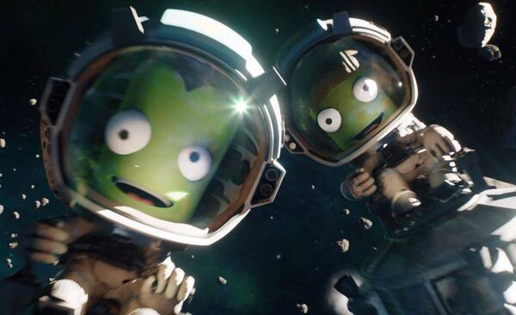Kerbal Space Program encourages kids to become acquainted with the laws of physics while sending rockets into space.
Kerbal Space Program isn’t an educational game – this is a straight up video game. Which is exactly what you need to get kids interested. The cute Kerbals want to go to space, but in order to do that, they need to obey the laws of physics. Kerbal Space Program does exactly what it suggests – making players build rockets to get into orbit, then construct space stations that work just as real space stations do. The game was praised by NASA for its adherence to physics, making this the perfect sneaky physics lesson.
World Rescue (Our recommended age 9+)
The winner of a UNESCO Gaming Challenge, in which more than 100 entries were received from 36 countries, World Rescue is an educational game through and through – but that doesn’t mean it’s not fun. With a heavy emphasis on narration and a fast pace, World Rescue sees players team up with five characters from Kenya, Norway, India, China and Brazil to fight sustainability problems like disease, drought, deforestation, all ‘at community level’. It’s free on Android and iOS.

Democracy (Our recommended age 12+)
With everything that has been in the US headlines recently, plus the ongoing challenge of governments to manage the pandemic, what better time to educate kids on political systems? Democracy will teach players about taxes, elections, funding, managing party structure – all while also learning about compromise and conflict resolution in negotiations. Of course, your children are already used to chaos and fighting from Fortnite and backstabbing from Among Us, so perhaps they are fully educated on politics as it is.
Minecraft (Recommended ages 7+)
By now, you are probably well aware of the educational value of Minecraft, but if not – like a piece of blocky earth in the game, it’s always worth breaking down. Minecraft has been packaged for the classroom and contains a free Education Edition that teaches kids a whole range of topics, like coding. In addition, the base game itself has long taught children how to think spatially, manage resources, and work with planning towards an end goal.

